An Bord Pleanála,
64 Marlborough Street,
Dublin 1.

03/07/24

I refer to the above application. The proposed windfarm works are located on high gradient lands within the Roughty_040 river catchment. The Roughty river is a high status water body. The receiving waters are the Thureehouma, Garrow and Glanlee streams, together the headwaters of other unnamed tributaries of the roughty river. These waters are of high fishery interest, with extensive salmonid spawning and nursery grounds throughout these systems, it is therefore essential the aquatic habitat and water quality is protected. These rivers should be considered high status waters and highly vulnerable to polluting inputs, habitat interference and hydrological changes.
The lands in question have shallow overburden of peat with limited vegetation cover. There is a high dynamic hydrological regime present due to the sites elevated location, high gradient and high rainfall. Extensive flood events are also a feature of the area.

The Board considers the environmental impact assessment report (EIAR) in support of this application and requires strict adherence to environmental protection measures identified.
The following comments and recommendations are relevant:

- An experienced Environmental officer is employed to oversee the project and protect the fishery habitat.

- Roads and stream crossings:
As part of the proposals for the upgrade of the existing road infrastructure, IFI seeks to ensure all watercourse crossings currently in place, upgraded or new, do not impede fish, including eel migration. IFI requires this be assured or crossings modified as part of planning if granted. Consultation with IFI required and crossing agreed as part of the planning licence if granted.
All watercourses should be effectively bridged/spanned prior to commencement of site development works with details provided on locations and design.

Bridging should be of a nature, which will not interfere with the natural streambed or its gradient.

Culvert pipes are not recommended as they increase flow velocities with the potential to cause erosion.
During construction, works should be undertaken in the dry by using cofferdams to divert flow or by pumping water passed the work areas.
Instream works to be carried out from July to September inclusive.

- Site Construction - Sediment Control.

Mitigation measures must be in place and functioning before any earthworks commence.
Addition measures may be included/necessary if works breach original measures. Silt control measures need to be regularly inspected, easily managed and maintained (Fencing is easily collapsed and can become ineffective without proper management on an ongoing basis such is not generally a feature of these sites.)
Machinery movement within buffer zones should be prohibited.

- Cement and Fuels.
Specific instruction should be given to contractors on the potential hazard to water quality when undertaking works close to watercourses and when using cement.

- Drainage of wet peat areas.
Drainage of these areas should be avoided or minimised.
Any forestry drainage system within the site should be back filled to prevent surface water flow through. Such work should be undertaken during dry weather conditions

- Alterations to watercourses.
Watercourses should not be diverted or altered as a result of this development.

- Timing:
Instream work or works likely to impact on water quality or habitats may only be carried out during the months July to September inclusive, with IFI consultation.

- Surveys:
IFI would require a combination of semi and fully qualitative and quantitative fisheries information on all aquatic habitats which may be affected. IFI requires a minimum of 1 site on each stream order.
Such assessments are to be carried out pre and post works and include control sites where applicable.
It is a requirement to apply for a section 14 permit from IFI prior to any electrofishing surveys.
Electrofishing is permitted from 1st of July to 30th September inclusive.

Water quality must also be assessed, using fauna/flora and chemical analysis pre, during and post works, for a minimum of 1 year after construction phase is completed. Information to be made available to IFI upon request.

Pre-development information should be of such nature and extent that it can be used for reference purposes and more importantly to identify if an impact (event) has occurred during the project’s developmental phase.

I would appreciate it if you would notify this office of any further progress on this proposal.

Yours sincerely,

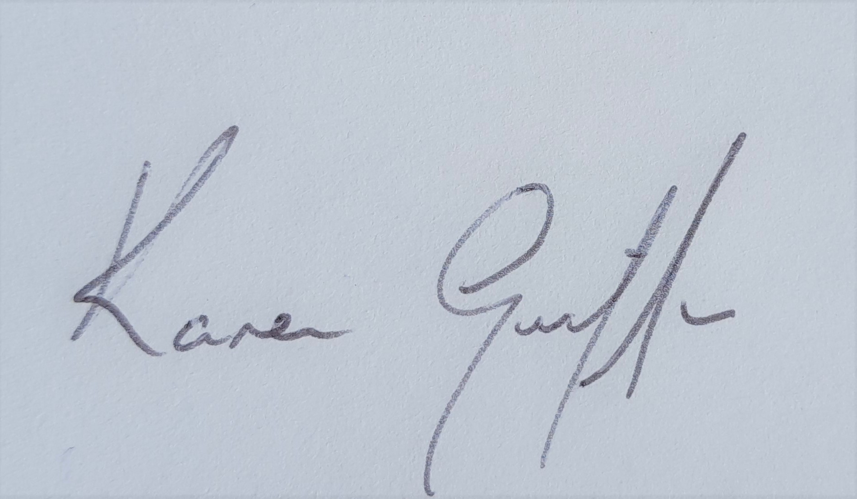
Karen Griffin
IFI Environmental Officer

